**School Health Advisory Council Academy ISD - Meeting #1**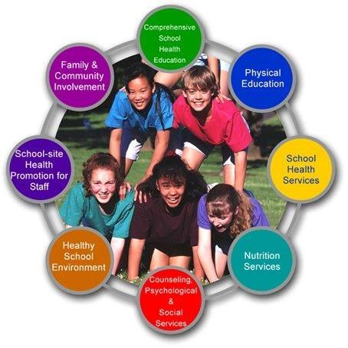

**for SY 2024-2025**

**November 21st, 2024 2:00 pm**

**AISD School Board Room**

AGENDA

1. Welcome

What is SHAC-School Health Advisory Council is a group appointed by the school district to serve at the district level. Members of the SHAC come from different areas of the community and from within the school district. SHACs assist the districts in ensuring that local community values are reflected in health education instruction. Additionally, SHACs play an important role in strengthening the connection between health and learning. They can help parents and community stakeholders reinforce the knowledge and skills children need to stay healthy for a lifetime.

1. Recap of last school year 23-24 SHAC

Review of Backpack Buddies presented by Kayla Andrews

Impact Counseling presented by AISD counselors.

New playground equipment for elementary and intermediate

1. Focus Item- Physical Education and Health Services
   1. Fitness gram-Coach Ramsey and Coach Vail
   2. Pre-Athletics and Athletics- Trainer Bailey Marks
   3. Flu shots provided to our district
   4. STOP THE BLEED will be offered to 6-12 grade student. With parent permission. HB 496
   5. MERT- presented by Mrs. Beck
2. Open Discussion/Question
3. Recommendations to be brought before the Board of Trustees, Closing Comments, Adjourn Meeting
4. Motion-
5. Second-